**DAILY ONLINE ACTIVITIES SUMMARY**

|  |  |  |  |  |  |  |  |
| --- | --- | --- | --- | --- | --- | --- | --- |
| **Date:** | **05 June 2020** | | | | **Name:** | **K ISHA HEGDE.** | |
| **Sem & Sec** | **4th sem, 2nd year** | | | | **USN:** | **4al18cs031** | |
| **Online Test Summary** | | | | | | | |
| **Subject** | | **--** | | | | | |
| **Max. Marks** | | **--** | | **Score** | | **----** | |
| **Certification Course Summary** | | | | | | | |
| **Course** | **INTRODUCTION TO FULL STACK DEVELOPMENT.** | | | | | | |
| **Certificate Provider** | | | **Great Learning** | **Duration** | | | **3hrs** |
| **Coding Challenges** | | | | | | | |
| **Problem Statement:1 program** | | | | | | | |
| **Status: Executed** | | | | | | | |
| **Uploaded the report in Github** | | | | **Yes** | | | |
| **If yes Repository name** | | | | **[https://github.com/iishaii/locked-down_coding](https://github.com/iishaii/locked-down_coding" \o "https://github.com/iishaii/locked-down_coding)** | | | |
| **Uploaded the report in slack** | | | | **Yes** | | | |

**Certification Course Summary:** **Today I started new certificate course through Great Learning I selected INTRODUCTION TO FULL STACK DEVELOPMENT. Today I learnt about front end , creating HTML file,HTML structure, Paragraph tags,More on head tags, Heading tags,HR and BR tags , anchor tags, absolute and relative path,link it online , image tags..etc.**

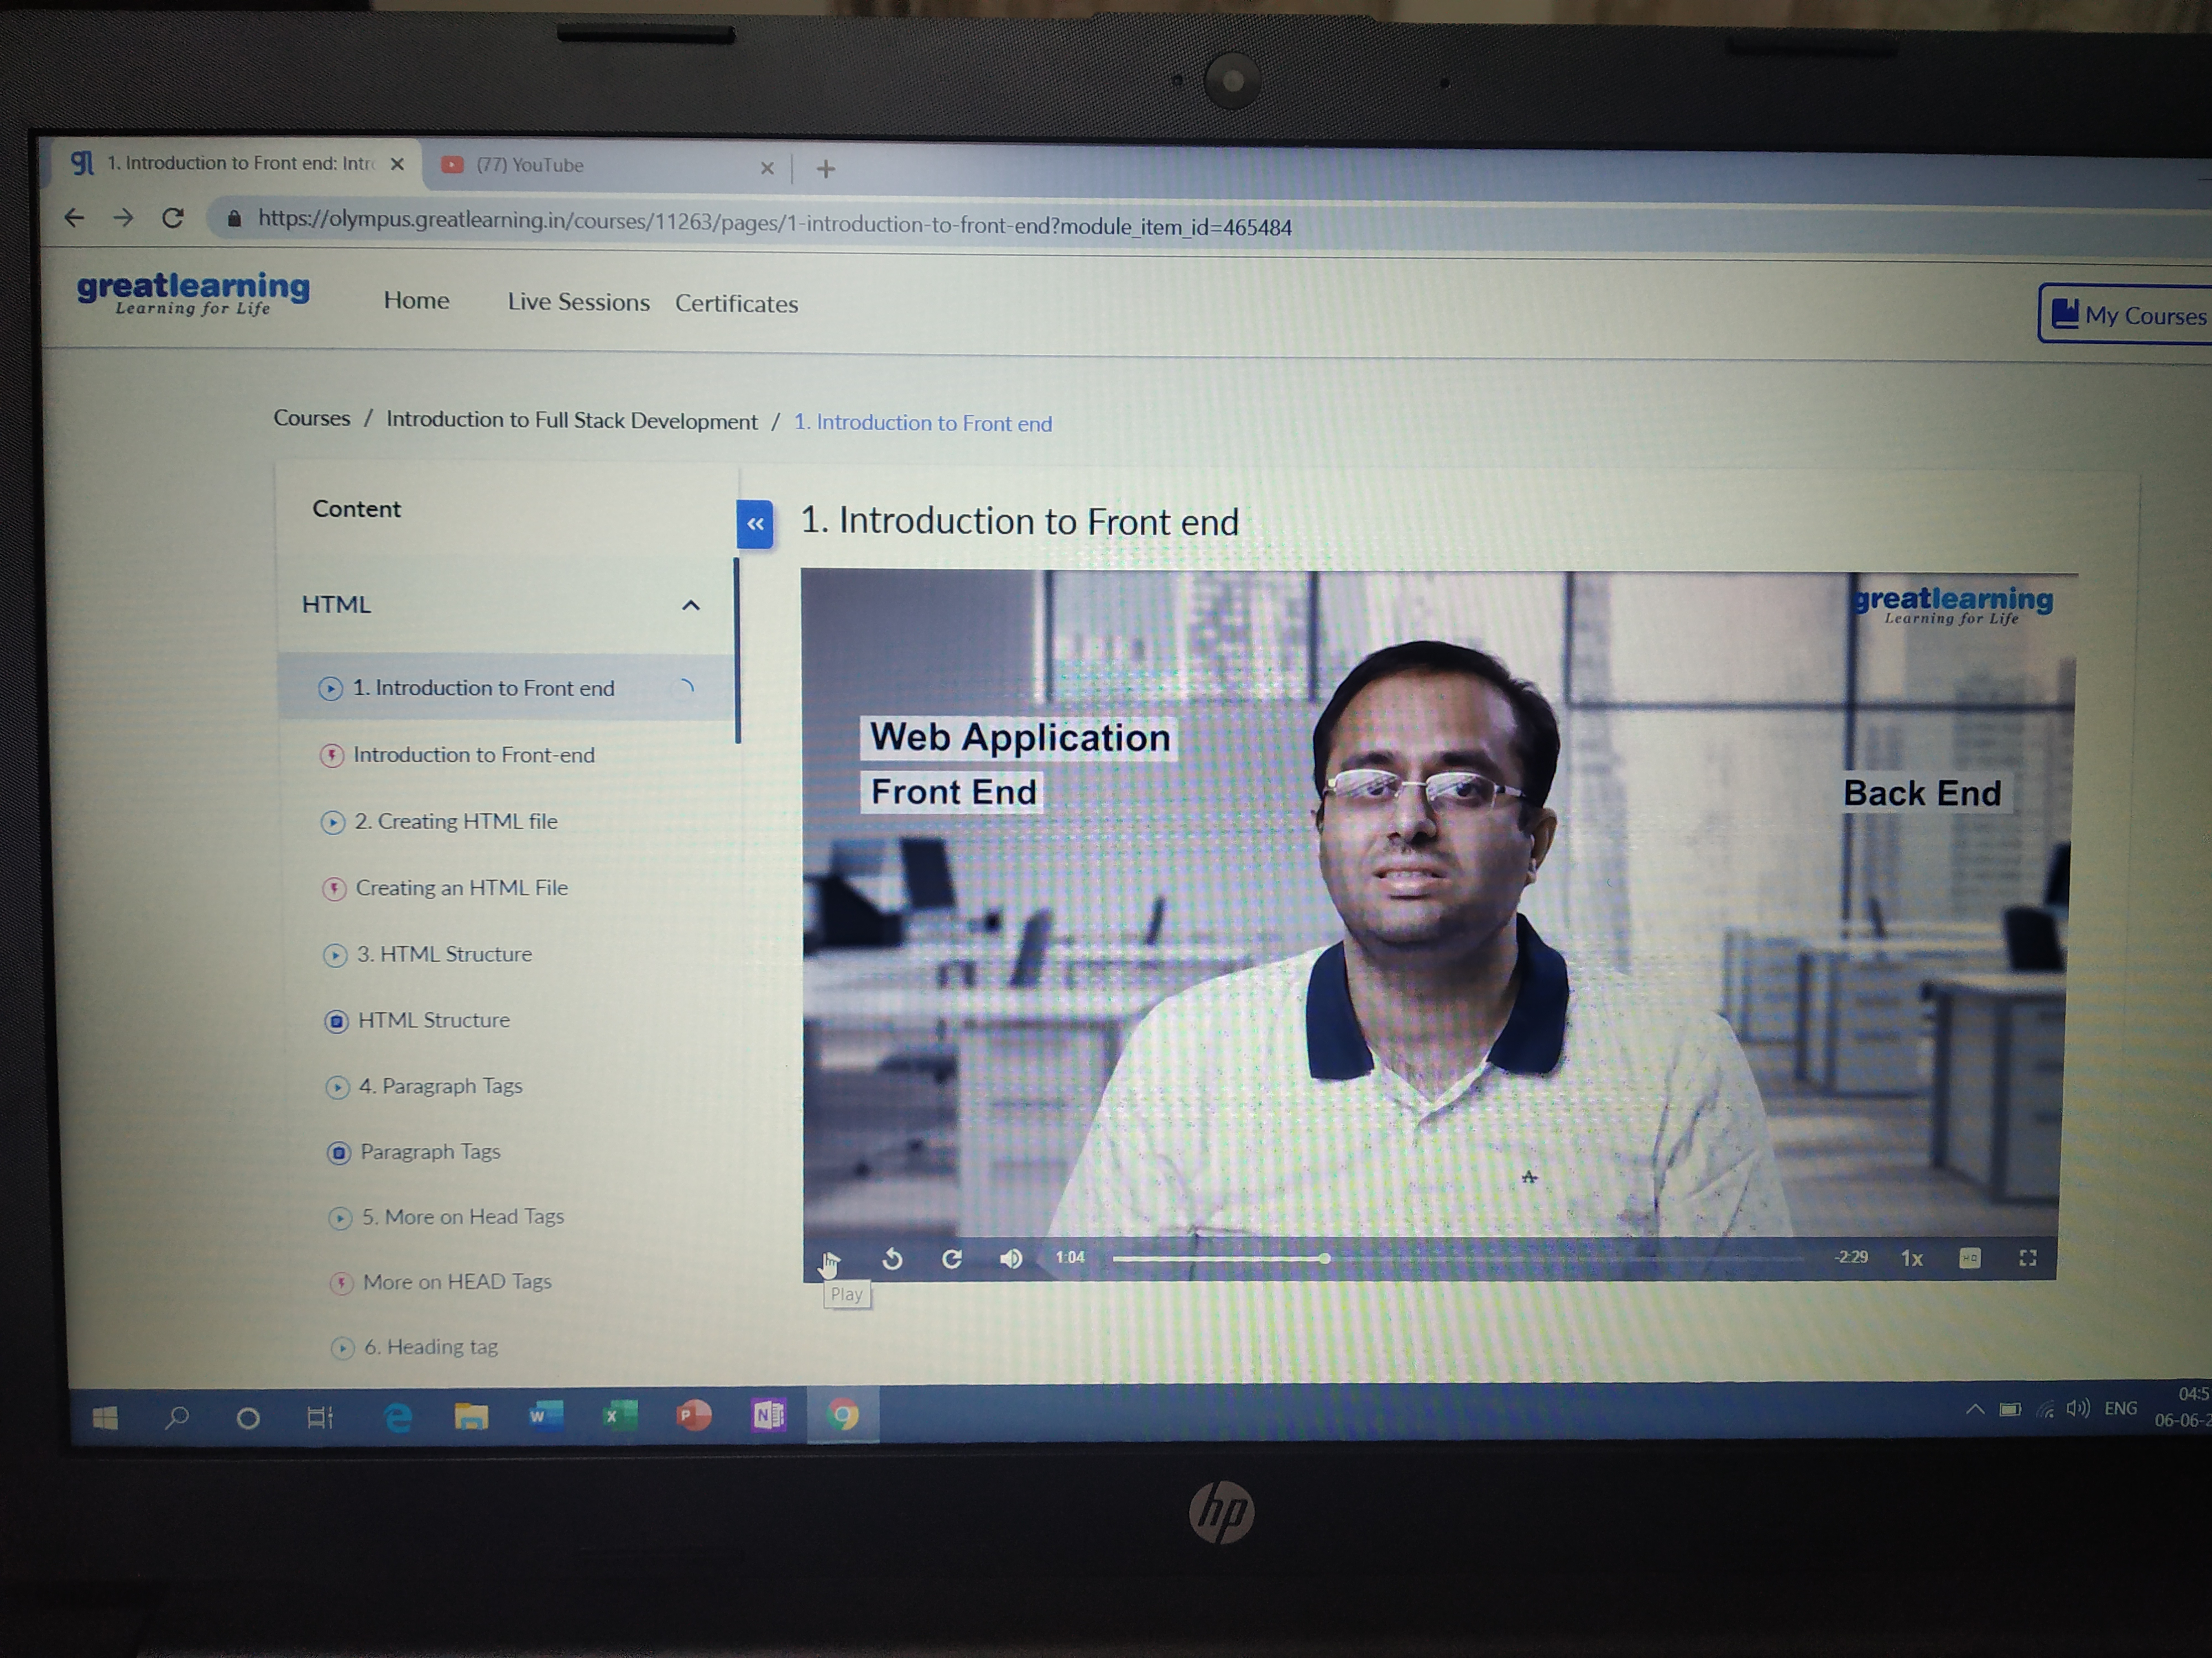

**And also I completed INTRODUCTION TO INFORMATION SECURITY and secured a certificate after attempting the final quiz today.I secured 95% .**

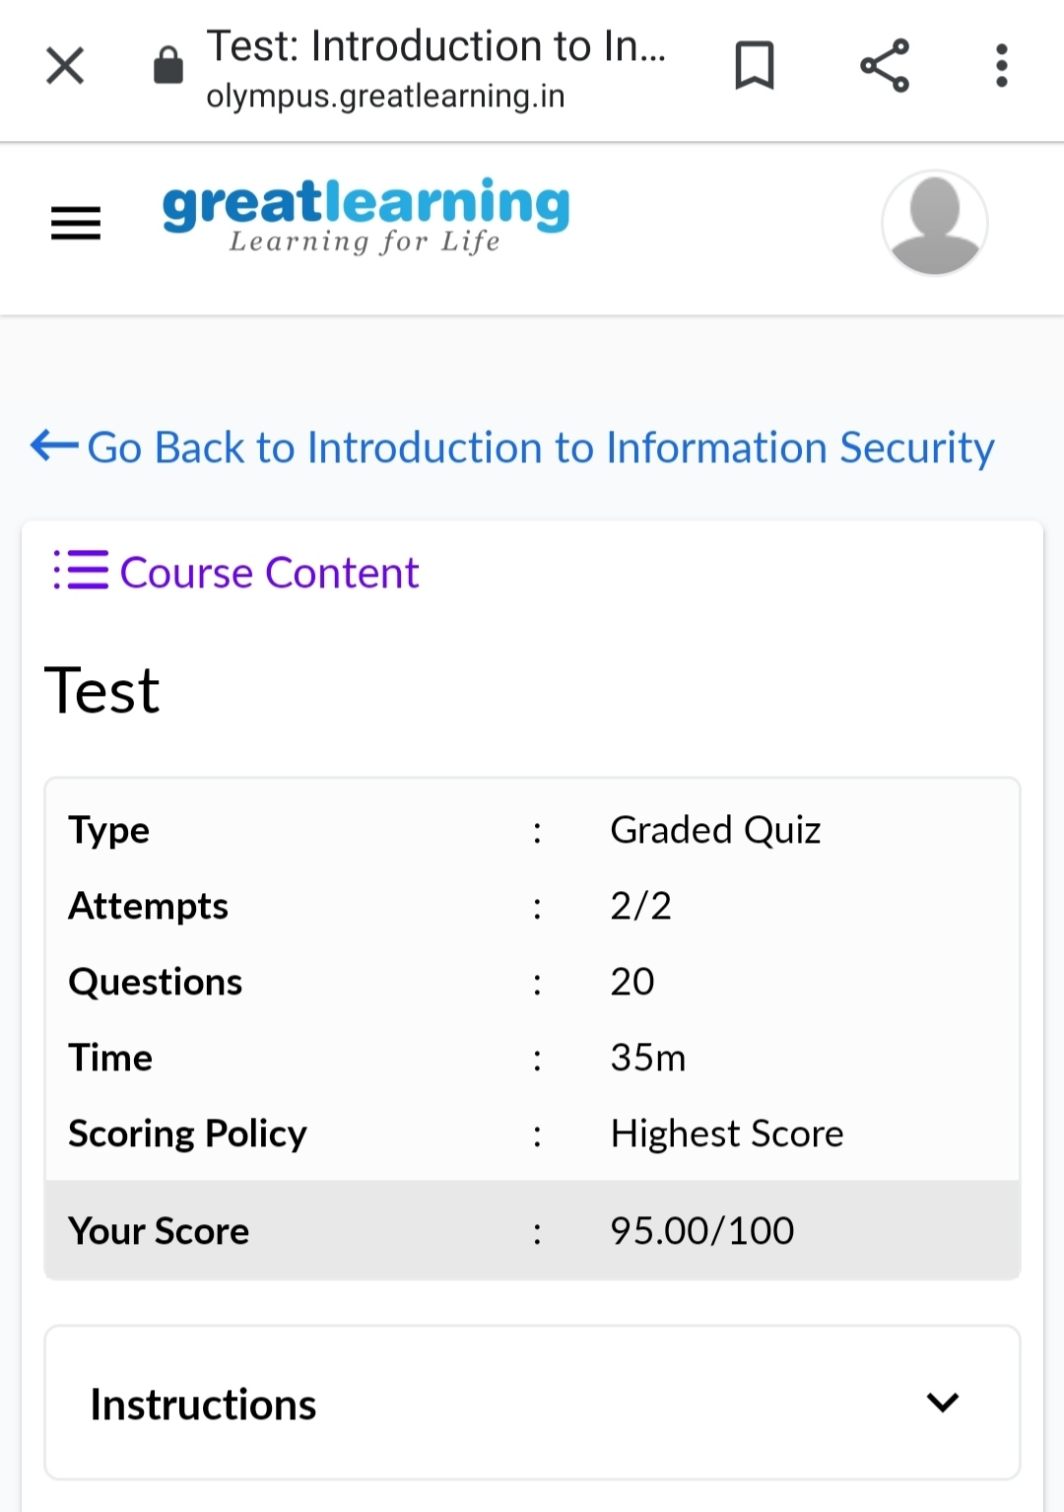

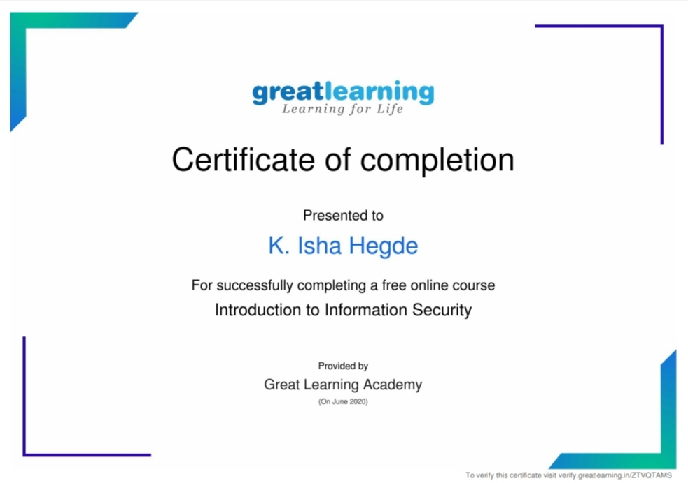

**Coding Challenges:**

Today I solved 1 coding challenge,

1. Write a Java Program to find the duplicate characters in a string.

